• Install Power BI Desktop and share the final screenshot of the report view page which appears when power desktop starts.

− Report View ( BOTH Questions are Answered )

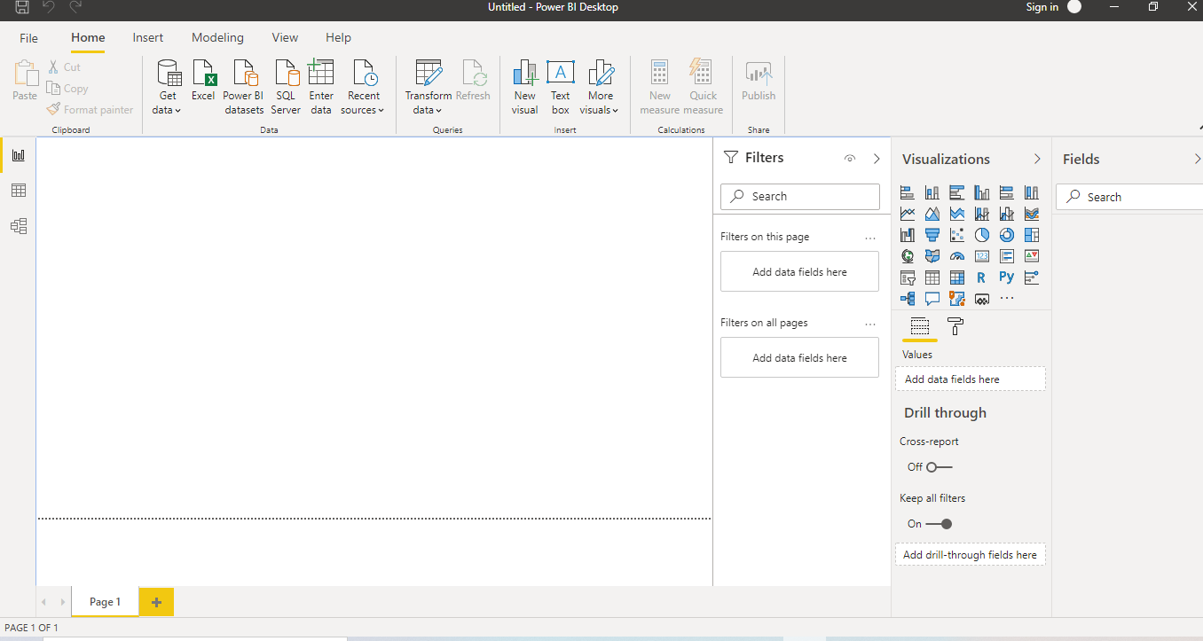

− Data View

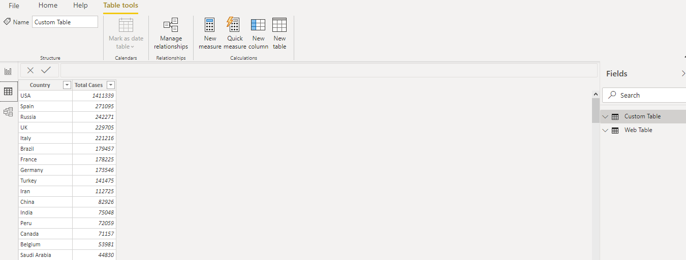

− Model View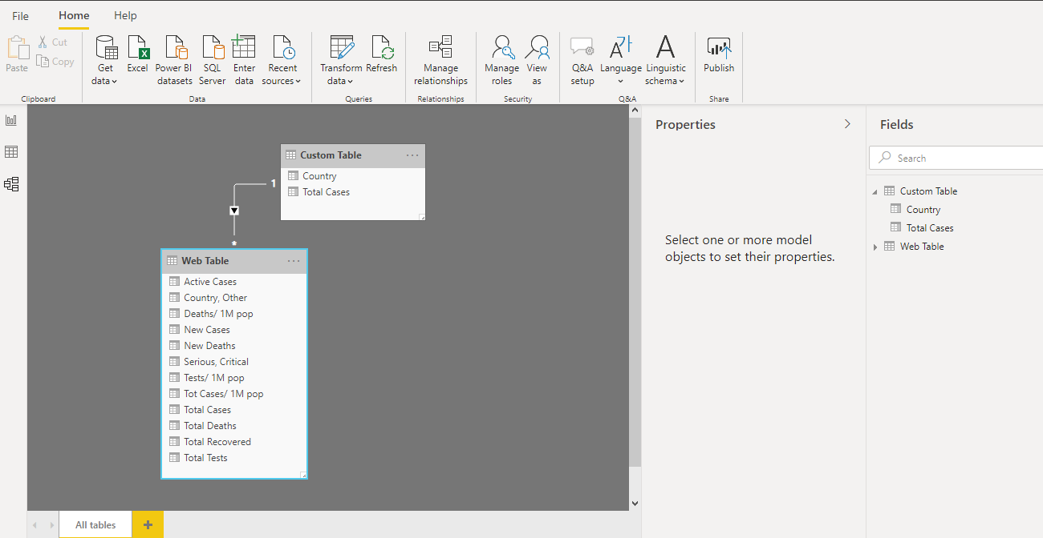

Power Query Editor

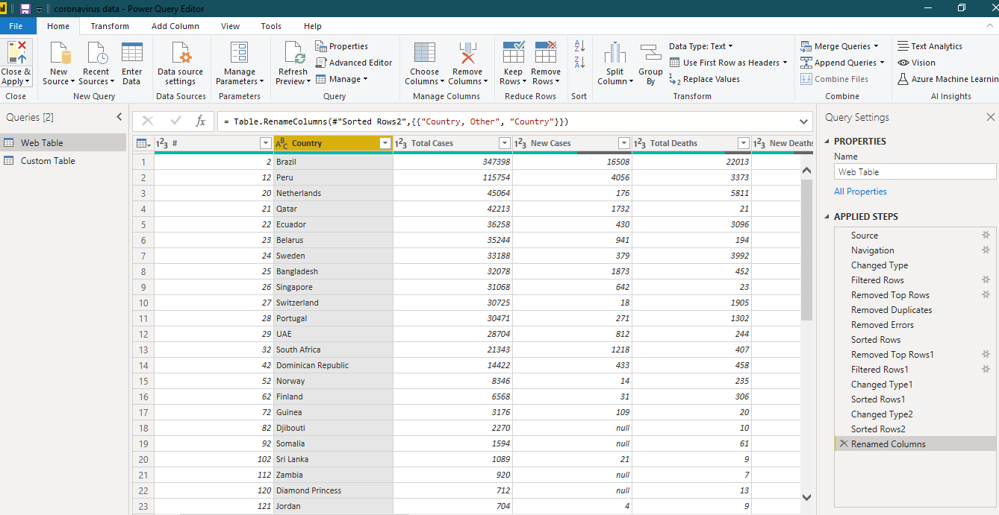

− Advance Editor

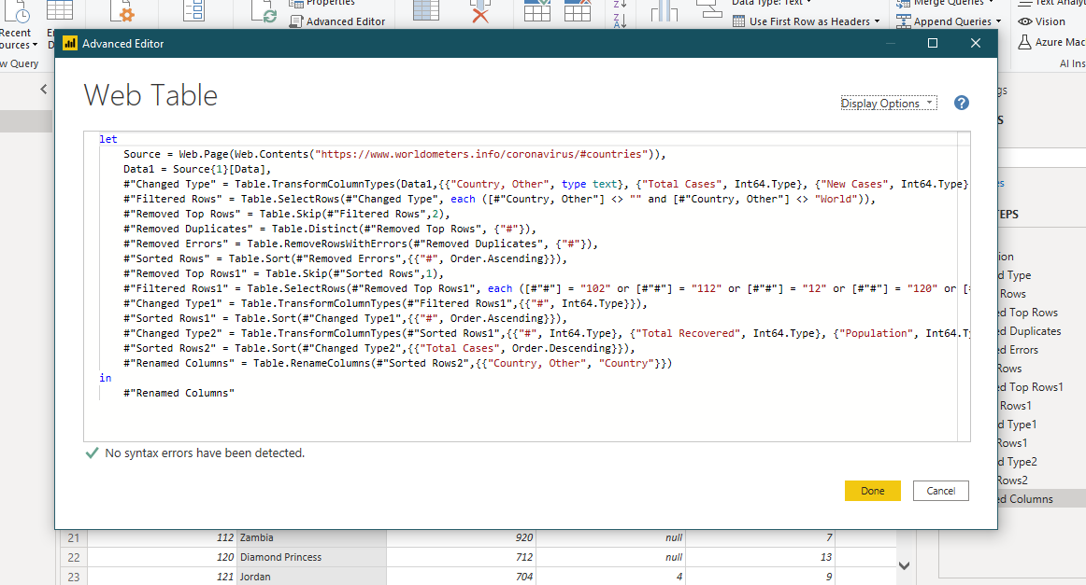

Prepare a document with details of the following along with their price

1. **Power BI Desktop** – Free of Cost.
2. **Power BI Pro -**  The Pro plan costs $9.99/user/month.
3. **Power BI Premium:** The Premium plan starts at $4,995 a month per dedicated cloud compute and storage resource.